


PROGRAMME : INTERNATIONAL TRADE

COURSE CODE : MFS 514

LECTURER : Dr GOVERA I.

NAME : NHONGO Leslie B243290B

Assignment 1
- Identify the global and regional trade agreements that Zimbabwe is a member of.
- Describe the trend of Zimbabwe’s major agricultural commodity imports and exports over the past 10 years.

Introduction
A trade agreement is a formal agreement (contract) between two or more countries on treatment to be given to goods and services originating from one country to the other and vice-versa. The scope of trade agreements includes a wide range of issues, namely:
Tariffs/Customs duty to be applied on imports from a signatory country; tax treatment with regard to Double Taxation Avoidance Agreements (DTAA) and taxing rights; investment with regard to Investment Promotion and Protection Agreements (IPPA) which provide protection to investments and investor’s rights; non-tariff measures that ensure no unnecessary obstacles are created on trade between signatory members; and movement of people, which allows for flexible entry and exit of people, through easy issuance of visas on arrival, or removal of visa requirements to travel between the signatory countries. Some agreements also cover hiring of labour.
Special Economic Zones, whereby a country offers concessions to another country to set-up special economic zones on its territory to set up export oriented enterprises

- Identify the global and regional trade agreements that Zimbabwe is a member of.
Zimbabwe is a member of several global and regional trade agreements that promote economic cooperation and facilitate trade among member states. Some of these agreements include the following:

Regional Trade Agreements

SADC (Southern African Development Community):
This is an organization with 16-member countries and its aim is to promote economic integration and cooperation in the region (ZimTrade, 2025) that is sustainable and equitable (SADC, 2022).

Common Market for Eastern and Southern Africa (COMESA)/ Preferential Trade Area (PTA) of Eastern and Southern Africa:
A regional trade bloc that allows reduced duties on imports from member countries (ZimTrade, 2025) and align the economic and monetary policies of its member states (COMESA,2018).
Allows reduced duties on imports from its 22 member countries subject to certain rules of origin (ZimTrade,2025).

Zimbabwe-Namibia Trade Agreement:
According to ZimTrade (2025),this agreement promotes trade cooperation and reduces tariffs on goods traded between the two countries. Some of the exports from Zimbabwe to Namibia are electricity, packaged medicaments and iron structures whilst Namibia exports non-fillet frozen fish, refined petroleum and poultry meat to Zimbabwe (ZimTrade,2024).

Zimbabwe-Botswana Trade Agreement:
This agreement enhances trade relations and provides preferential treatment for goods traded between the two countries such as raw sugar, wood and wood articles, dairy products and iron and steel products (OEC World, 2022).

Zimbabwe-South Africa Bilateral Trade Agreement:
Zimbabwe and South Africa trade precious minerals, tobacco, printed materials and coffee (Trade Economics, 2024). The trade agreement offers preferential rates of duty, rebates, and quotas on certain goods traded between the two countries (ZimTrade,2025).

African Continental Free Trade Area (AfCFTA) (Chawarika et al., 2022): Aims to create a single continental market for goods and services, promoting economic integration and cooperation among African countries. according to Ligami (2024), African Continental Free Trade Area is the world’s largest free trade area bringing together the 55 countries of the African Union (AU) and eight Regional Economic Communities (RECs) (ZIMRA,2025).

Global Trade Agreements

Cooperation Agreement between the National Assembly of Zimbabwe and the State Duma of the Federal Assembly of the Russian Federations (Parliament of Zimbabwe,2022). This agreement shape Zimbabwean tourism amongst other things.

Memorandum of Understanding on the Joint Economic and Trade Commission, Chinese Export-Import Bank loan that provided Zimbabwe with $1.2bn for in infrastructure development in 2015.

Belt Road Initiative with China (Educom, 2022)

EU-Eastern and Southern Africa (ESA) Interim Economic Partnership Agreement: Chawarika et al (2022) noted that ESA offers duty-free and quota-free market access to all exports from ESA countries, including Zimbabwe. ZNNC(2023) states that Zimbabwe and EU trade products of animal origin, cereals, beverages paper, plastics and rubber, textiles and clothing, footwear, glass and ceramics, consumer electronic and so on.

UK-ESA-EPA Economic Partnership Agreement: Provides preferential market access for Zimbabwean exports to the UK market (Chawarika et al., 2022). Zimbabwe-UK mostly trade horticultural products and some arts and crafts (Gakanje, 2024).

- Describe the trend of Zimbabwe’s major agricultural commodity imports and exports over the past 10 years.
Major Exports:
Tobacco (processed and unprocessed)
Soybean
Sugarcane
Cotton (ZimTrade,2025)
Major Imports:
Flour
Processed wheat
Machinery, including tractors and other agricultural equipment, ry.
Soybeans
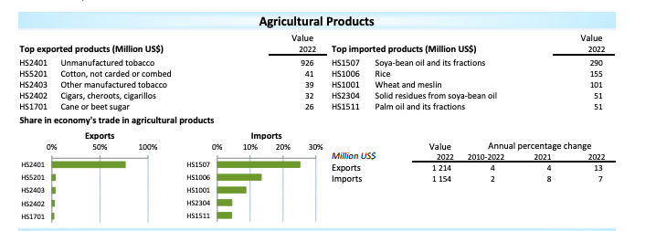
World Trade Organisation (2023)
According to World Trade Organisation (2023), Zimbabwe’s main export was unmanufactured tobacco. unmanufactured tobacco was exported more than it was imported. This can be attributed by the fact that there are a lot of small scale tobacco farmers in Zimbabwe who do contract farming. The graph also shows Zimbabwe imports less palm oil than it does soybean and rice. Rice and Soybean have high initial costs that cannot be met by a regular small scale farmer. Soybean and rice are the main imports as Zimbabwe’s soil and climate are not conducive to rice production. Soybean need sophisticated irrigation equipment that most small scale farmers cannot afford. Wheat comes in 3rd on the most imported agricultural commodity as Zimbabwean climate cannot produce the best wheat for bread and this has to be imported from Ukraine and Russia.
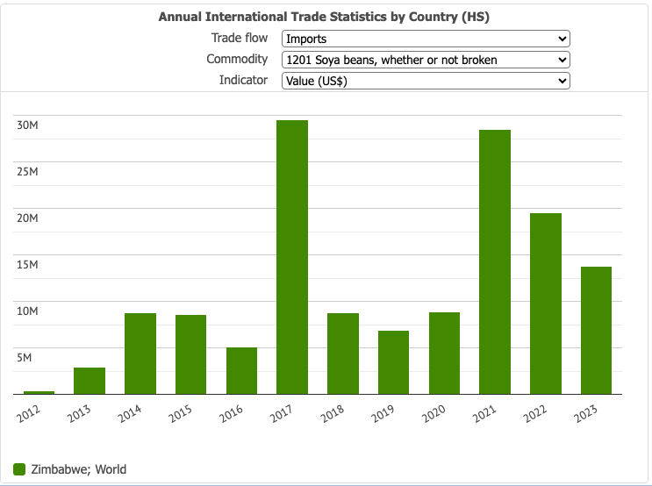
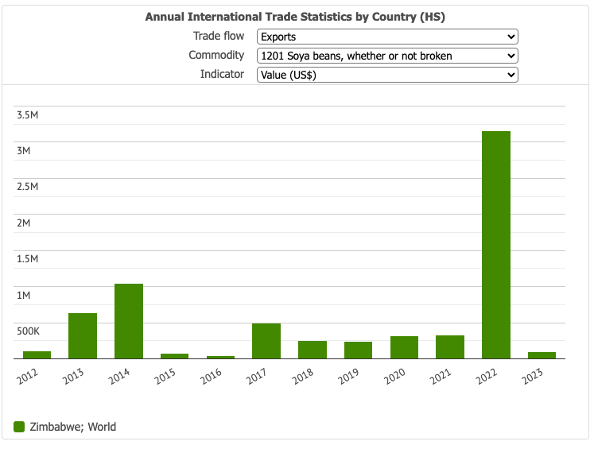
Trade Economy (2024).
Soybean imports have been severely high, as corroborated by Trade Economy (2024) with import values ranging from $5m to $30m between 2015 and 2023. Whilst exports have been extremely low:$2000k -$5000k, despite all government efforts. However, 2022 shows an outlier with a staggering $19 527 275.52 of soybean exported. According to ZEPARU (2017) Zimbabwe was working on a competitive value chain for soybean which may have seen this extensive export. The import of soybean was extremely high in 2017 and 2021 due to crop failures in Zimbabwe as a result of Cyclone Dineo. Prior to that, Zimbabwe had experienced severe drought from 2014-2016. In 2021, the large import of Soybean may have been due to effects of COVID 19 that restricted movement of goods so most farmers couldn’t farm due to lack of inputs. Also Cyclone Idai affected agricultural production.

Import value of machinery and mechanical appliances into Zimbabwe from 2015 to 2020(in million U.S. dollars)
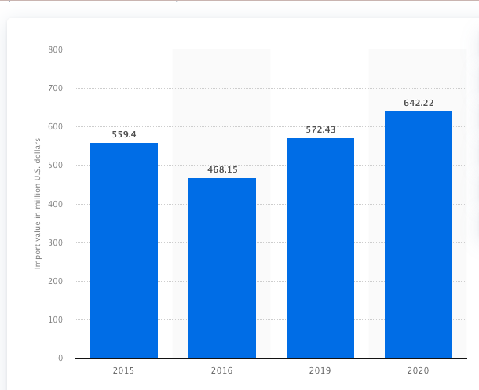
Crawling(2024)
This graph shows that imports of mechanical appliances to Zimbabwe have been increasing in the recent years due to initiatives by the government to improve agricultural production. Some of these innovations include HAFIZ, Command Agriculture, MIDP, John Deere mechanisation program, Agricultural mechanisation program and so on.

References
Chawarika, A., Madzokere, F. & Murimbika, A.2022. Regional trade agreements and agricultural trade: An analysis of Zimbabwe’s agricultural trade flows, Cogent Economics & Finance, 10:1, 2048482,

COMESA.2018.COMESA In Brief. Lusaka: COMESA

Gakanje, F. 2024. Zim-UK commit to Trade Collaboration. The Herald. https://www.herald.co.zw/zim-uk-commit-to-trade-collaboration/ [Accessed 23 January 2025]

Crawling, N.2024. Import value of machinery and mechanical appliances into Zimbabwe 2015-2020.
https://www.statista.com/statistics/1270658/import-value-of-machinery-and-mechanical-appliances-into-zimbabwe/. [Accessed 23 January 2025]

Educom. 2022. Zimbabwe and China trade agreements. https://educom.pt/site/2022/02/20/zimbabwe-and-china-trade-agreements/. [Accessed 23 January 2025]

Ligami, C. 2024. In Zimbabwe, small traders still await benefits of AfCFTA. African Business. https://african.business/2024/03/long-reads/traders-await-benefits-of-afcfta. [Accessed 23 January 2025]

Parliament of Zimbabwe. 2022. REPORT OF THE BILATERAL VISIT TO RUSSIA BY A PARLIAMENTARY DELEGATION LED BY HON. ADVOCATE JACOB FRANCIS NZWIDAMILIMO MUDENDA, SPEAKER OF THE PARLIAMENT OF THE REPUBLIC OF ZIMBABWE . 26 TO 30 SEPTEMBER 2022
SADC. 2022. SADC Objectives. Pretoria:SADC
Trade Economy.2024. Annual International Trade Statistics by Country (HS)
https://trendeconomy.com/data/h2/Zimbabwe/1201. [Accessed 23 January 2025]

World Trade Organisation.2023. Zimbabwe. https://www.wto.org/english/res_e/statis_e/daily_update_e/trade_profiles/ZW_e.pdf. [Accessed 23 January 2025]

ZEPARU. 2017. DEVELOPMENT OF A COMPETITIVE SOYA BEAN VALUE CHAIN OPPORTUNITIES AND CHALLENGES.

ZIMRA.2025. TAXMAN’S CORNER. https://www.zimra.co.zw/news/2213:exportation-of-goods-under-regional-trade-agreements-rta-free-trade-area-fta. [Accessed 23 January 2025]

Zimbabwe National Chamber of Commerce. 2023.Economic Partnership Agreements – Why Should You Care?. https://zncc.co.zw/index.php/news/20-events/29-economic-partnership-agreements-why-should-you-care.html. [Accessed 23 January 2025]

Zimtrade.2025. Trade Agreements. https://tradezimbabwe.com/trade-agreements/. [Accessed 23 January 2025]

